Strategic planning exercise for new Field applications
This form is intended to be a template for a discussion around the purposes and role of a new Field. It is not a full application (that comes in the next stage), but it provides sufficient detail to have a meaningful conversation about the value of establishing a new Field.
The process is as follows:

Rationale for the Field
  - What is the purpose of your Field
We have set out functional areas of Field activity, but every Field needs to have a clear purpose or mission for why it is important that this work happens. Also consider what Cochrane would miss out on if we do not establish this Field.

The Field in the broader Cochrane context
Cochrane is establishing CRG Networks, which will bring people in Cochrane together in new ways.
Please look at the full CRG transformation programme implementation plan when completing this section and in particular see the list of eight Networks: http://community.cochrane.org/news/structure-and-function-cochrane-review-groups-implementation-networks-and-editorial-board
Through this work we are bringing together people involved in prioritisation, production, dissemination and stakeholder engagement to build a more efficient Cochrane system. It is critical that Fields integrate with that system, but we have not defined exactly how that integration should happen yet.
  - Which Network do you feel most closely aligned to and why?

  - Do you think your Field could benefit from being integrated in a Network?

  - Do you think your Field would be constrained by being integrated into a Network? If so why?

Functional overview of the Field’s work
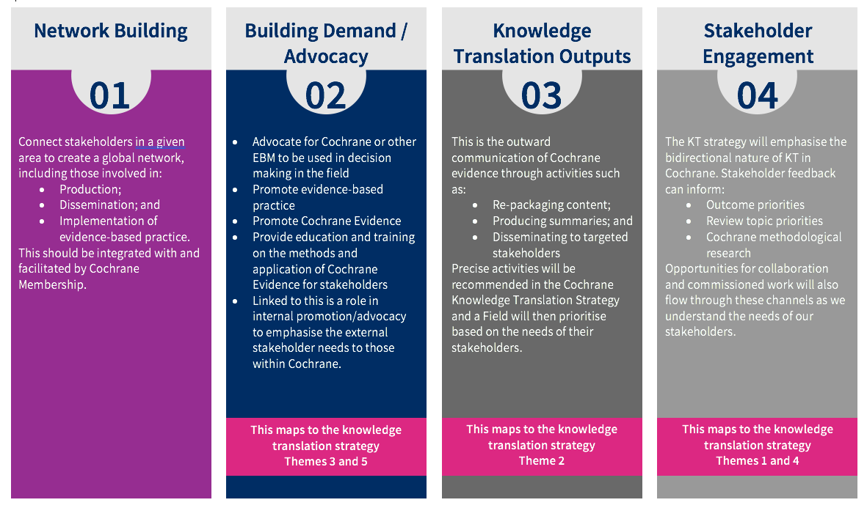
Please give an overview of what your Field would do in each of the of the four domains over the next three years. Further on in the process we will ask for a full strategic plan, but at this point in time we want only a summary of activities to demonstrate how the work of the Field aligns with these functional areas.

  - Network Building

  - Building demand/Advocacy

  - Knowledge Translation Outputs

  - Stakeholder Engagement

  - What other work would your Field undertake that falls outside of these four domains?

  - Does your proposed Field intend to be directly involved in review production? If yes, how?

Knowledge Translation (KT) Framework
The Cochrane Knowledge Translation Framework was approved in Geneva, April 2017, and is now moving into implementation. Throughout the development process we have stressed how important the framework is for Fields as so much activity in Fields is KT oriented.
The KT Framework, approved in April 2017, is available here:
http://community.cochrane.org/review-production/dissemination-resources/knowledge-translation-strategy/resources-knowledge-translation-strategy
The KT Framework Implementation Plan, approved in September 2017, is available here:
http://community.cochrane.org/sites/default/files/uploads/inline-files/3.3.1%20KTImplementationPlan_0.pdf
  - Please can you outline how you would respond to the KT Framework in your Field.
Theme one: Prioritization:

Theme two: Packaging and Push:

Theme three: Facilitating Pull:

Theme four: Exchange:

Theme five: Improving climate:

Theme six: Sustainable KT framework:

  - Please can you list the work packages that you are particular interested in within the KT Framework and outline what contributions you think you could make.

Funding and priorities for your Field
We appreciate that funders often influence priorities for Groups, so please help us to factor that in by providing information on this here.

  - Who would fund you and how sustainable would the funding be?

  - What are the priorities of the funder (with regard to your work)?

Geographical impact
By definition Fields are cross cutting and have relevance around the world. However, ensuring global impact is very challenging.
  - What would your Field do to try to have a broad geographical impact?

  - How would you seek to work with Cochrane’s global network of Centres to improve your global impact?

Strategic plan
If you already have a strategic plan, please attach it to this document.
The next stage in this process will be to draft a strategic plan for the Field. It is important that the strategic plan is clear about how the Group will address the four functional areas.
Please can you tell us how you would like to structure your strategic plan, so that we can talk through that structure and how it will communicate the links to the four dimensions of Fields activities before you complete the full plan.

This form uses Cochrane’s standard font: Source Sans Pro. If the form is not displaying appropriately please try installing Source Sans Pro, which is freely available here: https://www.fontsquirrel.com/fonts/source-sans-pro
See documentation available here: http://community.cochrane.org/sites/default/files/uploads/inline-files/11.2 Structure and Function Review of Cochrane Fields final design proposals - OPEN - website version.docx

