Strategic Plan Template for Cochrane Network

This document is applicable to a Cochrane Network only.

This Strategic Plan template is divided into six sections:
- The local environment in which the Network operates
- Current funder priorities / requirements
- How your Network will deliver its Cochrane functions
- Specialisms of the Network
- Challenges and Risks
- Network development and management
Appendix – Overview of functions and tiers – for information

The local environment in which the Network operates
- The use of evidence in your country or region

Please describe in brief (approximately 250 words) the state of the use of evidence in decision-making in your country/region and highlight where work needs to be done to improve the use of evidence or other gaps in the evidence system that you think the Cochrane Network needs to fill.
Please enter text here……….

- Priorities
What do you see as the highest priorities for Cochrane in your country/region, and which functional areas are the most important to your Network.
Please enter text here……….

Current funder/ host organisation priorities / requirements
Many funders/ host organisations of Centres and Networks add additional requirements to those needed by Cochrane (Section 3). Please list below what additional work you need to do to fulfil the requirements of your funders/ host organisation(s) above and beyond the those required by Cochrane.
Please enter text here……….

How your Network will deliver the Cochrane functions

The functions for Networks are those listed for Centres in the table below. Full details of the functions are available in Implementing Strategy to 2020: Cochrane Centres, Branches & Networks Structure & Function Review.
Networks are expected to respond to these functions in a way that is meaningful in their local context. This template, therefore does not list specific activities, but contains a column requesting details on how the Network intends to fulfil the function. Networks should complete this column with a detailed explanation of activities to be undertaken.
The functions in this form are organised around Cochrane’s four strategic goals:
GOAL 1: PRODUCING EVIDENCE: To produce high-quality, relevant, up-to-date systematic reviews and other synthesized research evidence to inform health decision-making.
GOAL 2: MAKING OUR EVIDENCE ACCESSIBLE: To make Cochrane evidence accessible and useful to everybody, everywhere in the world.
GOAL 3: ADVOCATING FOR EVIDENCE: To make Cochrane the ‘home of evidence’ to inform health decision-making, build greater recognition of our work, and become the leading advocate for evidence-informed health care.
GOAL 4: BUILDING AN EFFECTIVE & SUSTAINABLE ORGANISATION: To be a diverse, inclusive and transparent international organisation that effectively harnesses the enthusiasm and skills of our contributors, is guided by our principles, governed accountably, managed efficiently and makes optimal use of its resources.
The final column asks for targets against which the Network can be measured. You are invited to give short and long term targets for each functional area. Please ensure these targets are “SMART” (Specific, Measurable, Achievable, Relevant and Time bound). We advise short term targets to be for one year and long term targets to be for three years.
Under each Goal there is also a row for “Additional work the Centre carries out under Goal X”. This allows all Cochrane Groups greater freedom to perform other functions outside those required of their Group type. Networks therefore have the opportunity to specify other activities that they do which are worthy of note and should be tracked as part of their performance.
The functional areas in purple are the items in the additional ‘Tier 4’ functions which are not mandatory for Centres.
If you wish to see some examples of activities that might be under taken for each function please see Functions of Centres, Associate Centres, Affiliates and Networks.

Goal | Functional Area | Tier | How this function will be delivered | Short and long term “SMART” targets.
Goal One: Producing Evidence | To support Cochrane review production by providing local support, training and mentorship for Cochrane authors, editors and other contributors. | Two
 | To engage with external stakeholders locally to inform Cochrane’s review priority setting work. | Two
 | To undertake or contribute to methodological or other research supporting improved production or use of synthesised evidence. | Three
 | To undertake searching of local sources, especially non-English sources to contribute to the development of CENTRAL, Cochrane’s register of controlled trials. (Optional) | Four
 | Additional work the Network carries out under Goal One.

Goal | Functional Area | Tier | How this function will be delivered | Short and long term “SMART” targets.
Goal Two: Making our Evidence Accessible | To disseminate Cochrane Reviews locally based on stakeholder networks, the media and other communications channels. | One
 | To undertake Knowledge Translation (KT) work or work with other Groups in Cochrane to implement KT initiatives locally. | Three
 | To train the users of our evidence. | Two
 | To support the work of Cochrane’s consumer network by hosting/supporting a ‘consumer champion’. (Optional) | Four
 | To increase the accessibility of Cochrane Evidence in different languages. (Optional) | Four
 | To support student engagement with Cochrane through maintaining a local student network using the Students 4 Best Evidence brand and platform. (Optional) | Four
 | Additional work the Network carries out under Goal Two.

Goal | Functional Area | Tier | How this function will be delivered | Short and long term “SMART” targets.
Goal Three: Advocating for Evidence | To promote Cochrane and its work. | One
 | To be Cochrane’s official ‘Representative’ in the country/region. | Two
 | To build formal or informal local partnerships with key stakeholders to improve knowledge exchange and dissemination of Cochrane Evidence. | Two
 | To host local events such as country or regional symposia that promote the work of Cochrane, actively develop the contributor base, and build stakeholder links. | Two
 | To maintain a country/region advocacy programme in support of Cochrane’s mission, profile and agenda and provide a country/region voice for campaigns Cochrane is involved in. | Three
 | Additional work the Network carries out under Goal Three.

Goal | Functional Area | Tier | How this function will be delivered | Short and long term “SMART” targets.
Goal Four: Building an Effective and Sustainable Organisation | To support and develop the community of Cochrane members. | One
 | To act as a coordinating Centre for Cochrane activities in a country (including supporting CRGs, Fields or Methods Groups that are based in the country/region). | Three
 | To expand and diversify the funding base of Cochrane work in the country/region. | Three
 | Additional work the Network carries out under Goal Four.

Specialisms of the Network
Some Networks specialise in a certain function or area of work to some degree. Please give details of any particular specialisms of your Network, and where you feel that work in your specialist area means you are delivering less in other functional areas please explain this.
Please enter text here……….

Challenges and Risks
Please provide details of any challenges or risks that might affect your Network’s ability to complete its work over the next three years.
Please enter text here……….

Network Development and Management
- Network Development Plan
Networks can consist of any combination of Group types (Centres, Associate Centres, Affiliates), and there can be more than one Group in any given Country. Please provide us with details of how you envisage the Groups developing in your Network.
Include desired targets for how many Groups you are seeking to establish in the country/region and what sort of Group types they might be. Please also provide information on what you feel the priority areas of work will be for the different Groups.

Please enter text here……….

- Network Management
We have set out a policy for how accountability, support and mentorship should be established for Geographic Groups. Within Networks we provide discretion to the Network leadership to arrange this in the way that best suits the Network.
Please set out your approach to accountability, support and mentorship.

Please enter text here……….

- Network Leadership
Leadership is critical for Networks, particularly as they have so much delegated authority to manage Groups. Please provide details of how your Network leadership is configured and what governance oversight you have in place.

Please enter text here……….

Version control
Document created: | 9 September 2016
Document last updated: | April 2019
Document version: | 0.2
Document author: | Chris Champion (on behalf of CEOO)  Amended by Sylvia de Haan
Contact for queries: | sdehaan@cochrane.org

Appendix 1: Functions of Centres, Associate Centres, Affiliates and Networks
The functions of Centres and other geographic Cochrane groups are all directly built on Strategy to 2020 objectives. The functions are in a tiered hierarchy. Tier One functions must be performed by any Cochrane Group, however big or small. Tier Two functions must be performed by Associate Centres and Centres. Tier Three are functions that Centres must perform as well as those in Tiers One and Two. Tier Four are additional functions that any Cochrane Group would be encouraged to consider, however, Centres must perform at least one Tier Four function. A Network is encouraged to perform the functions of a Centre – with each Network member performing tasks from the various Tiers.

  - The functions at a glance
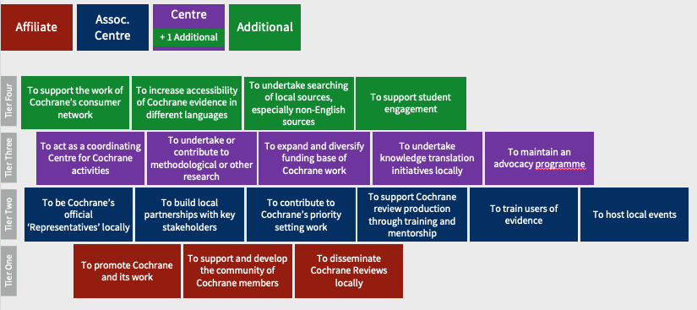

How the tiers map to Groups

See: Accountability, Support and Reporting Policy for Geographic Groups

