Strategic Plan Template for Cochrane Centres

This document is applicable to Centres only.

This Strategic Plan template is divided into six sections:
- The local environment in which the Centre operates
- Current funder priorities / requirements
- How your Centre will deliver its Cochrane functions
- Specialisms of the Centre
- Challenges and Risks
- Development Plan
Appendix – Overview of functions and tiers – for information

The local environment in which the Centre operates
- The use of evidence in your country or region
Please describe in brief (approximately 250 words) the state of the use of evidence in decision-making in your country and highlight where work needs to be done to improve the use of evidence or other gaps in the evidence system that you think the Cochrane Centre needs to fill.
Please enter text here……….

- Priorities
What do you see as the highest priorities for Cochrane in your country, and which functional areas are the most important to your Centre.
Please enter text here……….

Current Funder/host organisation priorities / requirements
Many funders/ host organisations of Centres add additional requirements to those needed by Cochrane (Section 3). Please list below what additional work you need to do to fulfil the requirements of your funders/ host organisation above and beyond the those required by Cochrane.
Please enter text here……….

How your Centre will deliver its Cochrane functions

The functions for Centres are outlined in the below table. Full details of the functions are available in Implementing Strategy to 2020: Cochrane Centres, Branches & Networks Structure & Function Review.
Centres are expected to respond to these functions in a way that is meaningful in their local context. This template, therefore does not list specific activities, but contains a column requesting details on how the Centre intends to fulfil the function. Centres should complete this column with a detailed explanation of activities to be undertaken.
The functions in this form are organised around Cochrane’s four strategic goals:
GOAL 1: PRODUCING EVIDENCE: To produce high-quality, relevant, up-to-date systematic reviews and other synthesized research evidence to inform health decision-making.
GOAL 2: MAKING OUR EVIDENCE ACCESSIBLE: To make Cochrane evidence accessible and useful to everybody, everywhere in the world.
GOAL 3: ADVOCATING FOR EVIDENCE: To make Cochrane the ‘home of evidence’ to inform health decision-making, build greater recognition of our work, and become the leading advocate for evidence-informed health care.
GOAL 4: BUILDING AN EFFECTIVE & SUSTAINABLE ORGANISATION: To be a diverse, inclusive and transparent international organisation that effectively harnesses the enthusiasm and skills of our contributors, is guided by our principles, governed accountably, managed efficiently and makes optimal use of its resources.
The final column asks for targets against which the Centre can be measured. You are invited to give short and long term targets for each functional area. Please ensure these targets are “SMART” (Specific, Measurable, Achievable, Relevant and Time bound). We advise short term targets to be for one year and long term targets to be for three years.
Under each Goal there is also a row for “Additional work the Centre carries out under Goal X”. This allows all Cochrane Groups greater freedom to perform other functions outside those required of their Group type. Centres therefore have the opportunity to specify other activities that they do which are worthy of note and should be tracked as part of their performance.
The functional areas in purple are the items in the additional ‘Tier 4’ functions which are not mandatory for Centres.
If you wish to see some examples of activities that might be under taken for each function please see Functions of Centres, Associate Centres, Affiliates and Networks.

Goal One: Producing Evidence
Functional Area | Tier | How this function will be delivered | Short and long term “SMART” targets.
To support Cochrane review production by providing local support, training and mentorship for Cochrane authors, editors and other contributors. | Two
To engage with external stakeholders locally to inform Cochrane’s review priority setting work. | Two
To undertake or contribute to methodological or other research supporting improved production or use of synthesised evidence. | Three
To undertake searching of local sources, especially non-English sources to contribute to the development of CENTRAL, Cochrane’s register of controlled trials. (Optional) | Four
Additional work the Centre carries out under Goal One.

Goal Two: Making our Evidence Accessible
Functional Area | Tier | How this function will be delivered | Short and long term “SMART” targets.
To disseminate Cochrane Reviews locally based on stakeholder networks, the media and other communications channels. | One
To undertake Knowledge Translation (KT) work or work with other Groups in Cochrane to implement KT initiatives locally. | Three
To train the users of our evidence | Two
To support the work of Cochrane’s consumer network by hosting/supporting a ‘consumer champion’. (Optional) | Four
To increase the accessibility of Cochrane Evidence in different languages. (Optional) | Four
To support student engagement with Cochrane through maintaining a local student network using the Students 4 Best Evidence brand and platform. (Optional) | Four
Additional work the Centre carries out under Goal Two.

Goal Three: Advocating for Evidence
Functional Area | Tier | How this function will be delivered | Short and long term “SMART” targets.
To promote Cochrane and its work. | One
To be Cochrane’s official ‘Representative’ in the country. | Two
To build formal or informal local partnerships with key stakeholders to improve knowledge exchange and dissemination of Cochrane Evidence. | Two
To host local events such as country or regional symposia that promote the work of Cochrane, actively develop the contributor base, and build stakeholder links. | Two
To maintain an advocacy programme in support of Cochrane’s mission, profile and agenda and provide a country voice for campaigns Cochrane is involved in. | Three
Additional work the Centre carries out under Goal Three.

Goal Four: Building an Effective and Sustainable Organisation
Functional Area | Tier | How this function will be delivered | Short and long term “SMART” targets.
To support and develop the community of Cochrane members. | One
To act as a coordinating Centre for Cochrane activities in a country including supporting CRGs, Fields or Methods Groups that are based in the country. | Three
To expand and diversify the funding base of Cochrane work in the country | Three
Additional work the Centre carries out under Goal Four

Specialisms of the Centre
Most Centres specialise in a certain function or area of work to some degree. Please give details of any particular specialisms of your Centre. Where you feel that work in your specialist area means you are delivering less in other functional areas please explain this.
Please enter text here……….

Challenges and Risks
Please provide details of any challenges or risks that might affect your Centre’s ability to complete its work over the next three years.
Please enter text here……….

Development Plan
It is possible and encouraged to establish multiple presences in a country or region. Whilst this is not a mandatory step, please consider whether you expect to establish Affiliates or Associate Centres in your country or region, and if so what would be the plan for this.
Please enter text here……….

Version control
Document created: | 9 September 2016
Document last updated: | April 2019
Document version: | 0.3
Document author: | Chris Champion (on behalf of CEOO)  Amended by Sylvia de Haan
Contact for queries: | sdehaan@cochrane.org

Appendix 1: Functions of Centres, Associate Centres, Affiliates and Networks
The functions of Centres and other geographic Cochrane groups are all directly built on Strategy to 2020 objectives. The functions are in a tiered hierarchy. Tier One functions must be performed by any Cochrane Group, however big or small. Tier Two functions must be performed by Associate Centres and Centres. Tier Three are functions that Centres must perform as well as those in Tiers One and Two. Tier Four are additional functions that any Cochrane Group would be encouraged to consider, however, Centres must perform at least one Tier Four function. A Network is encouraged to perform the functions of a Centre –with each Network member performing tasks from the various Tiers.

The functions at a glance
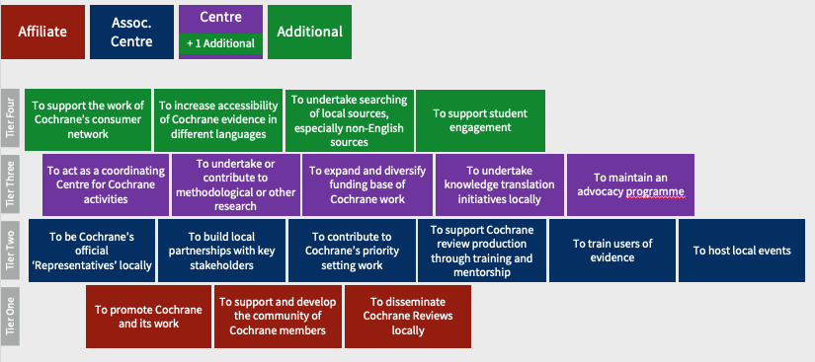

How the tiers map to Groups

