Strategic Plan Template for Cochrane Affiliates

This document is applicable to Affiliates only.

This Strategic Plan template is divided into six sections:
- The local environment in which the Affiliate operates
- Current Funder priorities / requirements
- How your Affiliate will deliver its Cochrane functions
- Specialisms of the Affiliate
- Challenges and Risks
- Development Plan
Appendix – Overview of functions and tiers – for information

The local environment in which the Affiliate operates
- The use of evidence in your country, organisation or institution

Please describe in brief (approximately 250 words) the state of the use of evidence in decision-making in your constituency (your organization; the stakeholders you work with; or the geographic area your Group would cover) and highlight where work needs to be done to improve the use of evidence or other gaps in the evidence system that you think the Cochrane Affiliate needs to fill.
Please enter text here……….

- Priorities
What do you see as the highest priorities for Cochrane in your constituency, and which functional areas are the most important to your Affiliate?
Please enter text here……….

Current Funder/ host organisation priorities / requirements
Many funders/ host organisations add additional requirements above those stipulated by Cochrane. Please list below what additional work you need to do to fulfil the requirements of your funders/host organisation above and beyond the requirements Cochrane sets.
Please enter text here……….

How your Affiliate will deliver its Cochrane functions

The functions for Cochrane Affiliates are outlined in the below table. Full details of the functions are available in Implementing Strategy to 2020: Cochrane Centres, Branches & Networks Structure & Function Review.
Affiliates are expected to respond to these functions in a way that is meaningful in their local context. This template, therefore does not list specific activities, but contains a column requesting details on how the Affiliate intends to fulfil the function. Affiliates should complete this column with a detailed explanation of activities to be undertaken.
The functions in this form are organised around Cochrane’s four strategic goals:
GOAL 1: PRODUCING EVIDENCE: To produce high-quality, relevant, up-to-date systematic reviews and other synthesized research evidence to inform health decision-making.
GOAL 2: MAKING OUR EVIDENCE ACCESSIBLE: To make Cochrane evidence accessible and useful to everybody, everywhere in the world.
GOAL 3: ADVOCATING FOR EVIDENCE: To make Cochrane the ‘home of evidence’ to inform health decision-making, build greater recognition of our work, and become the leading advocate for evidence-informed health care.
GOAL 4: BUILDING AN EFFECTIVE & SUSTAINABLE ORGANISATION: To be a diverse, inclusive and transparent international organisation that effectively harnesses the enthusiasm and skills of our contributors, is guided by our principles, governed accountably, managed efficiently and makes optimal use of its resources.
The final column asks for targets against which the Affiliate can be measured. You are invited to give short and long term targets for each functional area. Please ensure these targets are “SMART” (Specific, Measurable, Achievable, Relevant and Time bound). We advise short term targets to be for one year and long term targets to be for three years.
Under each Goal there is also a row for “Additional work the Affiliate carries out under Goal X”. This allows all Cochrane Groups greater freedom to perform other functions outside those required of their Group type. Affiliates therefore have the opportunity to specify other activities that they do which are worthy of note and should be tracked as part of their performance.
The functional areas in purple are the items in the additional ‘Tier 4’ functions which are not mandatory for Affiliates.
If you wish to see some examples of activities that might be under taken for each function please see Functions of Centres, Associate Centres, Affiliates and Networks.

Tier 1: Core Functions of Affiliates
These are the three core functional areas of Affiliates. All Affiliates must complete these functions.

Functional Area | How this function will be delivered | Short and long term “SMART” targets.
Goal Two: Making our Evidence Accessible
To disseminate Cochrane Reviews locally based on stakeholder networks, the media and other communications channels.

Goal Three: Advocating for Evidence
To promote Cochrane and its work.
Goal Four: Building an Effective and Sustainable Organisation
To support and develop the community of Cochrane members.

Tier 4: Additional Functions
There is no expectation that Affiliates will take on additional functions, in fact we expect most will not do so. However, where local funding or other factors allow Affiliates to take on more than the core functions, they can add them in this section so that this additional contribution to Cochrane is captured.
The additional functions available to all Centres, Associate Centres and Affiliates are listed here along with a more generic section referred to as “Additional Work”. By Additional work we mean any other activities you undertake as a Cochrane Group that you would like to record as part of your contribution to Cochrane.
Functional Area | Tier | How this function will be delivered | Short and long term “SMART” targets.
Goal One: Producing Evidence
To undertake searching of local sources, especially non-English sources to contribute to the development of CENTRAL, Cochrane’s register of controlled trials. (Optional) | Four
Goal Two: Making our Evidence Accessible
To support the work of Cochrane’s consumer network by hosting/supporting a ‘consumer champion’. (Optional) | Four
To increase the accessibility of Cochrane Evidence in different languages. (Optional) | Four
To support student engagement with Cochrane through maintaining a local student network using the Students 4 4 Best Evidence brand and platform. (Optional) | Four
Additional work
Additional work the Affiliate carries out under Goal One.
Additional work the Affiliate carries out under Goal Two.
Additional work the Affiliate carries out under Goal Three.
Additional work the Affiliate carries out under Goal Four.

Specialisms
Most Affiliates specialise in a certain function or area of work to some degree. Please give details of any particular specialisms of your Affiliate, and where you feel that work in your specialist area means you are delivering less in other functional areas please explain this.
Please enter text here……….

Challenges and Risks
Please provide details of any challenges or risks that might affect your Affiliate’s ability to complete its work over the next three years.
Please enter text here……….

Development plan
Please provide details of any plans you may have to grow your Affiliate’s activities; or develop into becoming an Associate Centre. Please note, it is not a requirement that Affiliates develop into Associate Centres.

Please enter text here……….

Version control
Document created: | 9 September 2016
Document last updated: | April 2019
Document version: | 0.3
Document author: | Chris Champion (on behalf of CEOO)  Amended by Sylvia de Haan
Contact for queries: | sdehaan@cochrane.org

Appendix 1: Functions of Centres, Associate Centres, Affiliates and Networks
The functions of Centres and other geographic Cochrane groups are all directly built on Strategy to 2020 objectives. The functions are in a tiered hierarchy. Tier One functions must be performed by any Cochrane Group, however big or small. Tier Two functions must be performed by Associate Centres and Centres. Tier Three are functions that Centres must perform as well as those in Tiers One and Two. Tier Four are additional functions that any Cochrane Group would be encouraged to consider, however, Centres must perform at least one Tier Four function. A Network is encouraged to perform the functions of a Centre – with each Network member performing tasks from the various Tiers.

  - The functions at a glance
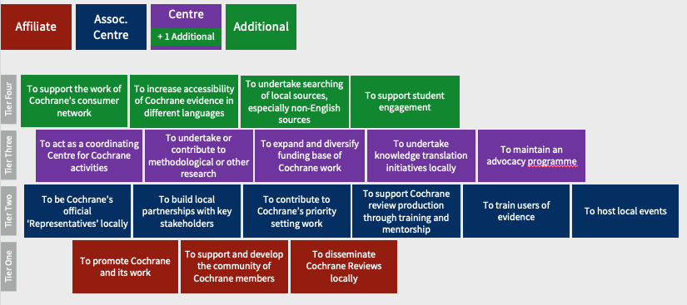

How the tiers map to Groups

