Monitoring and Registration Group Report
to the Cochrane Collaboration Steering Group

- How many meetings, and of what type (e.g. face-to-face or by teleconference), has your Advisory Group had since March 2004?

The MRG met face-to-face for four days during June 2004, in Oxford. The activities of the MRG have continued with adequate consultation by e-mail as necessary.
Is this what you expected in your previous report?

Yes.

- Supply an up-to-date list of the members of your Advisory Group.

Kathie Clark (Co-Convenor), Jon Deeks, Jodie Doyle (on maternity leave until January 2004), Sally Green (Co-Convenor), Sally Hopewell (non-elected member), Steff Lewis (incoming Co-Convenor), Heather Maxwell (non-elected member), Karen New (non-elected member), Janet Wale, Mingming Zhang (non-elected member).

- Summarise any significant actions taken by your Advisory Group since your last report (for the Steering Group meeting in Barcelona in October 2003), and significant actions planned for the next eight months until the next meeting of the Steering Group in Ottawa in October 2004.

  - In the last six months:

Actions taken in monitoring entities for January to December 2003:

Monitoring forms were sent to all entities on 22 January 2004. Completed forms were discussed at the face-to-face meeting in June 2004, reports were written for all entities and entities have had the chance to feed back comments on their report. The Consumer Network was not monitored for the period January – December 2003, because of its ongoing review and redevelopment. Key issues and actions arising from this year’s monitoring process are included below:

- Copy-editing: Guidance about use of the copy-editing facility provided by John Wiley and Sons was issued with all CRG reports.

- Communication within the Collaboration: The MRG advised all entities to read the report about cross-cultural communication that was prepared for the Steering Group by Michele Deeks.

- CRG editors as reviewers: In response to feedback from CRGs, the MRG came to a consensus that it was not appropriate (in some instances) for all CRG editors to have authored a Cochrane review (e.g., editors with special functions or advocacy roles). However, the MRG will ask CRGs to continue to encourage the majority of their editors to author a Cochrane review. This was fed back to all CRGs on their monitoring reports.

- Effective use of TSCs: A theme starting to arise through the monitoring reports of CRGs, which the MRG believes should be encouraged, is the sharing of a TSC post across neighbouring CRGs. In an effort to facilitate this, Sylvia Bickley and Karen Blackhall (TSCs in this position) have been asked to write an article for Cochrane News and CCInfo, as other groups might be considering the same model.

- Minor updates of reviews: In order to recognise that minor updates can take as much time and resource for the editorial base as substantive updates, the Handbook Advisory Group (HAG) has been asked to consider the guidance constituting a minor update.

- Dual reporting: In response to many comments about the frustration of having to report both to the MRG and to their funder, the MRG has re-affirmed the continued need for dual reporting as requirements vary, both between different funding bodies, and from the information required by the MRG.

- Updating CRG modules: In an effort to facilitate up-to-date modules, the MRG has raised whether the ‘date last updated’ could be added as a field to CRG modules (as for the modules of other entities), and that the Editorial Management Advisory Group (EMAG) consider issuing guidance that modules are updated at least once every twelve months.

- Workload of Methods Group Convenors: The MRG has suggested to some Methods Groups, that, in order to share the workload, that they follow the successful model of the Statistical Methods Group and consider recruiting Co-Convenors who would be responsible for specific tasks.

- Geographical location of Convenors of Methods Groups: The MRG is seeking clarification over where the entity base of some Methods Groups is located. It was agreed that when there is a change of Convenor, the MRG would seek to clarify if the entity base was moving location. It was also agreed that the location of the entity base would be requested through the annual monitoring process.

- TSCs workload in relation to CENTRAL: The MRG has acknowledged a potential problem for TSCs as workload is anticipated to increase because of the number of records in an incorrect format in CENTRAL. CCAG have asked the CRGs to be responsible for ‘cleaning up’ their own records. Previously the US Cochrane Center undertook this task, but funding is no longer available for this. Some CRGs have a very large number of problematic citations and coupled with this, the TSC post within a CRG is more likely to be a part-time post. It will undoubtedly affect the time available to search for, and send, new citations to reviewers.

Additional Actions in the past six months

- New entities: Two new Fields were registered: Prehospital and Emergency Health (Convenor: Frank Archer), and Occupational Health (Convenor: Jos Verbeek).

- Proposed new entities: Heather Maxwell attended the meeting of the proposed Behavioural and Psychosomatic Medicine Field (proposed Convenor: Karina Davidson) on 25 August 2004. Registration documents have been received from the proposed Information Retrieval Methods Group (proposed Co-Convenors: Carol Lefebvre and Steve Pritchard), and we continue to work with the proposed Equity in Health Care Field (proposed Convenor: Peter Tugwell), and the proposed Childhood Cancer CRG (proposed Co-ordinating Editor: Leontien Kremer).

- Monitoring process: The MRG has revised the outline of the monitoring process, which has been included in The Cochrane Manual. A suggested change to the frequency of monitoring has been submitted to the Steering Group as a separate paper.

- Perspectives of other users of entities: The MRG discussed the issue of trying to gather perspectives of reviewers and consumers at its face-to-face meeting in June 2004. It is known that there is variability in the way CRGs support both consumers and reviewers, and this issue will be discussed at the RGCs/TSCs meeting during the Ottawa Colloquium. The QAG has been asked to consider a project about reviewer and consumer support at its Ottawa meeting.

- Recruitment of new members: The MRG is currently trying to recruit a TSC representative and will approach individuals. Attempts to recruit a Co-ordinating editor have not been successful, but we do have an editor member and are working on facilitating better communication with Co-ordinating editors.

- Time expectations/ roles of editorial base staff: The registration criteria for new CRGs state that there should be 1.0 combined FTE for a RGC/TSC role, and 0.1 for a Co-ordinating Editor. The MRG has asked the Co-ordinating Editors to discuss the appropriate FTE expectations for different sized groups at their meeting in Ottawa and registration will be considered in light of this.

- Satellites of CRGs, Branches of Centres and Sub-Groups of Methods Groups and Fields: As increasing numbers of entities are establishing ‘outposts’, generally in a different country to the entity base, the MRG is faced with keeping track of these and deciding on the best way in which to effectively monitor them. The MRG has written a paper proposing a model for this and put it to the RGCs’, TSCs’, Co-ordinating Editors’ and Centre Directors’ meetings during the Ottawa Colloquium for feedback. We will revise the paper in light of this feedback and then will submit it to the Steering Group for approval. In the meantime, the MRG agreed that the ‘Changes to entities’ document should be changed to reflect that when a Branch, Satellite or Subgroup is proposed, it would have the status ‘Approval’, and letters of support would be required (see Appendix 1). In addition a request for Part B to be completed for all branches, satellites and subgroups has been added to the Monitoring Form

- Membership of the MRG: The MRG agreed that CCSG members would naturally rotate off the MRG at the same time as they rotated off the Steering Group. In addition, it was agreed that non-elected members may remain on the MRG for two, three-year terms, but that in order to ensure continuity, there should be a system of rotation, with not more than half the MRG members stepping down in any one year.

  - In the next eight months:

- Registration project: The MRG is in the process of evaluating the registration criteria and checklists, and will ensure they are up-to-date in The Cochrane Manual for new entities during the year 2005.

- Frequency of monitoring: This has been put to the Steering Group in a separate item. Based on the outcome of this item, a new frequency of monitoring may be implemented in next eight months, requiring dissemination to entities, revision of forms and implementation of increased entity support.

- New co-convenors: Kathie Clark will stand down as a member of the MRG at the Ottawa meeting to take on her new role as Co-chair of the Collaboration. Sally Green will remain Co-convenor and Steff Lewis will replace Kathie as Co-convenor. We would like to thank Kathie for the enthusiastic, sensitive, positive, capable and enormous contribution she has made to the MRG.

- Does your Advisory Group have any questions that you would like the Steering Group to answer? If so, please list them.

- Coverage: In its Melbourne meeting the MRG asked the Steering Group to consider the current and future ‘coverage’ of the Collaboration with respect to geographic regions and areas of healthcare. We consider this particularly important to guide decisions about the registration of future entities based on need. Nick Royle was requested to map the current coverage and provide advice about any gaps. At later meetings it was decided that Nick’s primary task was in fundraising and management and the coverage project was delegated back to the MRG. The MRG have started the process of establishing a Working Group, to make preliminary investigations into the 'coverage' of Centres, CRGs and Methods Groups. This working group will be chaired by Kathie Clark and include representation from CRGs and Satellites, Centres and Branches, Methods Groups (and in particular the Applicability and Recommendations Methods Group), Fields, the Developing Counties Initiative and the Consumer Network. It will report back to the MRG and the MRG in turn will inform the Steering Group.

Does the CCSG endorse the formation of this working group and are there any specific tasks the CCSG would like to advise at inception?

- Compliance with registration criteria: Currently entities are monitored against core functions. All registration requirements are not reflected in core functions (for example the amount of time spent on core Collaboration work, interactions with and support for other entities). It is proposed that, after the registration criteria for all entity types are updated, that the MRG develop a method for ensuring compliance with registration criteria in addition to core functions.

Does the CCSG endorse the development of a proposal regarding encouraging compliance with registration criteria?

- Co-convenors of the MRG: The MRG would like to propose to the Steering Group that it might be appropriate for a non-elected member of the MRG to become a Co-Convenor. We propose that one Co-convenor should be a CCSG member, but in the interests of continuity and sharing of workload, the other Co-convenor, if selected by the MRG, may be a non-CCSG member. This is consistent with Advisory Groups (eg HAG, QAG).

Does the Steering Group endorse this potential new arrangement?

- Improving communication about the outcomes of monitoring. The MRG would like to communicate the common themes resulting from each year’s monitoring to the entity representatives in a separate report to encourage discussion at appropriate entity meetings.

Does the Steering Group endorse this?

- Does your Advisory Group wish to raise any problems, and recommended solutions, which you would like the Steering Group to discuss? If so, please list them.

- Funding: The MRG would like the Steering Group to note that availability of funding is a universal problem, and a common issue reported by all entities. Many entities report that they do not have sufficient funding to perform their core functions. These entities are included in the ‘List of entities about which the MRG is concerned’ in Appendix 2.

- Fields working with CRGs: The MRG has noted increasing numbers of reports from Fields of difficulty in communicating with CRGs. Members of the MRG will discuss this with RGCs and TSCs at their Ottawa meeting. The MRG would like the Field and CRG representatives on the Steering Group to consider ways of facilitating interaction between Fields and CRGs.

- Updating Cochrane reviews: The MRG has noted increasing numbers of CRGs with many out-of-date reviews. The MRG would like to recommend that the Steering Group convene a working group to discuss solutions to the problems that CRGs are facing in facilitating the updating of reviews (see Appendix 3 – graphs).

- Public access to MRG reports submitted to the Steering Group: The MRG would like to recommend that its report to the Steering Group continues to be made public, but that the list of those entities about which the MRG is concerned remains confidential to the Steering Group.

- RGC morale: The MRG has noted that RGC morale seems to be low. It may or may not be attributable to workload and we suggest that more support for RGCs may be needed. The MRG recommends that the Steering Group consider methods of supporting RGCs, including employing a central post providing RGC support, although it recognises that the new IMS support positions may assist with this. We recommend a review of this once the IMS support roles are implemented.

- Fields meeting their core functions: Many Fields are reporting that meeting their core functions can be problematic and a larger proportion of Fields than any other entity are listed as entities about which the MRG is concerned. The MRG would like the Steering Group to consider asking the Field representatives to investigate this and advise on initiatives to support Fields.

- Summary of 2003 Monitoring: In an effort to summarise the main findings of this year’s monitoring, Steff Lewis, at the request of the MRG has prepared summary graphs (see Appendix 2).

- Eighty of 82 entities returned monitoring forms. Those entities not returning forms have been reminded on many occasions.
- There are nine entities about which the MRG is concerned.
- There were 78 withdrawn publications from The Cochrane Library during 2003 (see Appendix 3).

- Budget
The MRG has not spent the full budget allocated at the CCSG meeting in Bergamo. It is likely that the budget will be under spent at the year-end. It is planned to use part of this surplus to support the working group looking at coverage.

Kathie Clark and Sally Green
Co-Convenors
Monitoring and Registration Group
September 2004

APPENDIX 1: MAJOR OR MINOR CHANGES TO ENTITIES:
RECOMMENDATION FROM THE MONITORING AND REGISTRATION GROUP

APPROVAL: Changes requiring approval. (Please send details of proposed change to the Secretariat Deputy Administrator (callen@cochrane.org).)
NOTIFICATION REQUIRED: Changes where immediate notification is required. (Please send notification to the Secretariat Deputy Administrator (callen@cochrane.org).)
NOTIFICATION REQUESTED: Changes where notification is requested through the annual monitoring process.

CHANGES AFFECTING ALL ENTITIES | STATUS
Relocation of entity from one country to another | Approval (letter of support required)
Relocation of entity within a country | Notification required
Division of entity (e.g. based in different locations) | Notification required
Change of primary funders | Notification required
Change of registered name | Approval
Significant reduction in resources available (e.g. drop of more than 20%) | Notification required
Significant increase in resources available (e.g. rise of more than 20%) | Notification requested
Closure of entity | Approval
Change of legal status or governance (e.g. registering as a company or charity) | Approval
Change of status to a Cochrane-Campbell entity | Approval

CHANGES AFFECTING CRGs ONLY | STATUS
Change of Co-ordinating Editor | Notification required
Change of editors or other members of staff | Notification requested
Change of scope of CRG | Approval
Merger with another CRG | Approval
Significant changes in editorial practice | Notification requested
Establishment of satellites (letter of support required from the reference Cochrane Centre of the country where the of the satellite will be located, and the country where the editorial base is located) | Approval

CHANGES AFFECTING CENTRES ONLY | STATUS
Change of Centre Director | Notification required
Change of other members of staff | Notification requested
Change of special function | Approval
Change of a Centre Branch Director | Notification required
Establishment of Branches (letter of support required from the reference Cochrane Centre of the country where the of the satellite will be located, and from entities based in the country where the Branch will be located) | Approval

CHANGES AFFECTING FIELDS AND THE CONSUMER NETWORK ONLY | STATUS
Change of Co-ordinator | Notification required
Change of other members of staff | Notification requested
Change of registered scope | Approval
Merger with another Field | Approval
Establishment or change to new or ongoing bursary schemes | Notification required

CHANGES AFFECTING METHODS GROUPS ONLY | STATUS
Change of Convenor | Notification required
Change of other members of staff | Notification requested
Change of registered scope | Approval
Merger with another Methods Group | Approval
Establishment of sub-groups (letter of support required from the Methods Group concerned, and from the reference Cochrane Centre of the country where the of the sub-group will be located) | Approval

APPENDIX 2: SUMMARY GRAPHS

REVIEWS

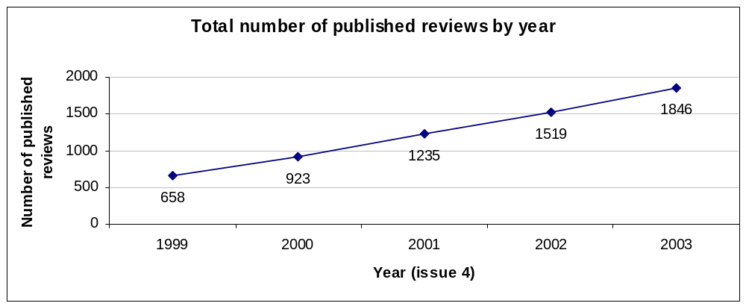

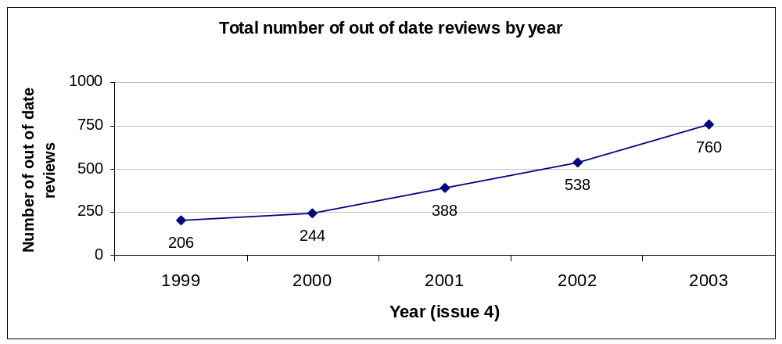
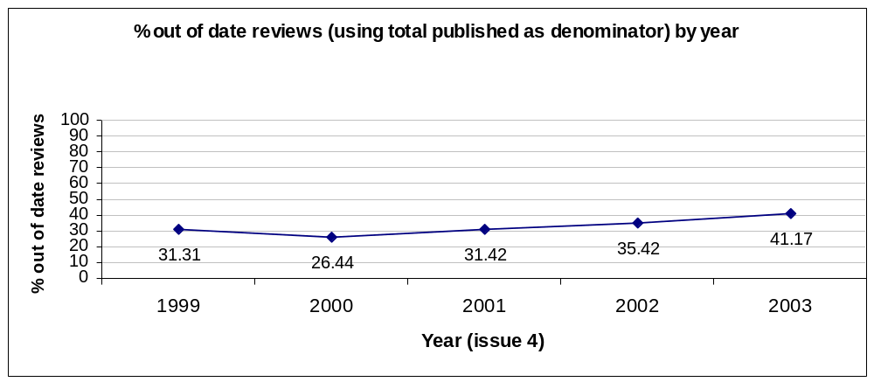

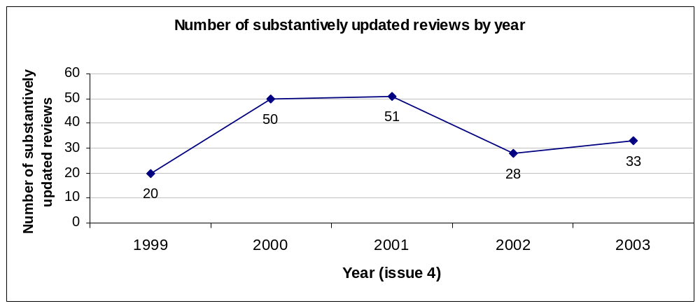
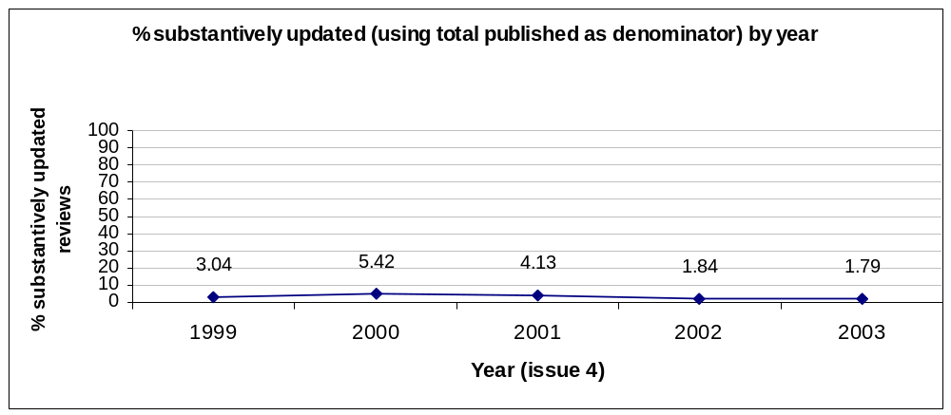

PROTOCOLS

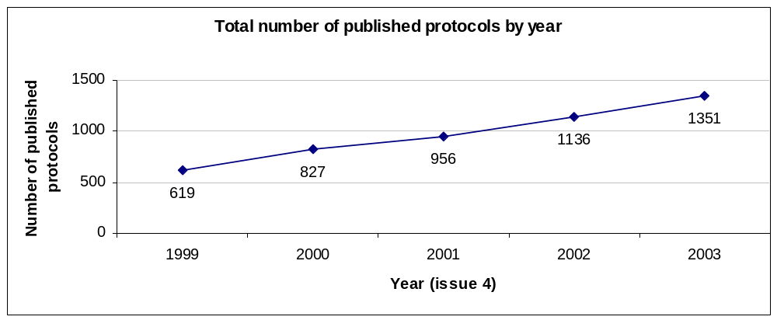

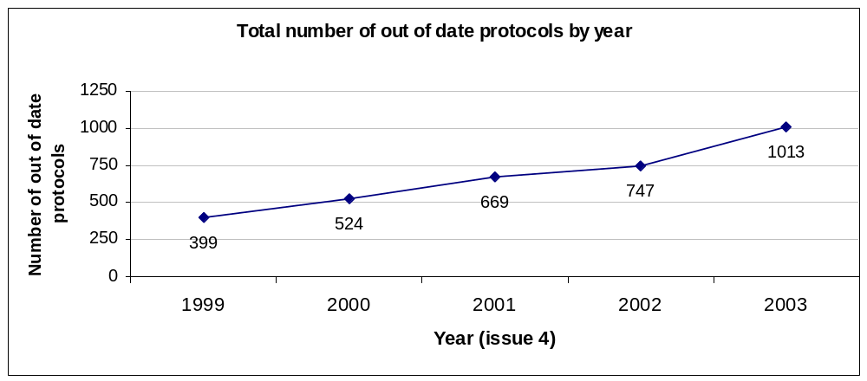

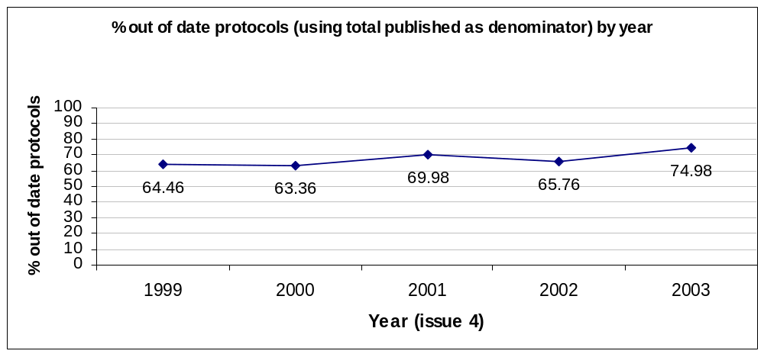

SPREAD ACROSS CRGs

In the following plots, the box represents the interquartile range. The whiskers extend from the box to the highest and lowest values. A line across the box indicates the median.

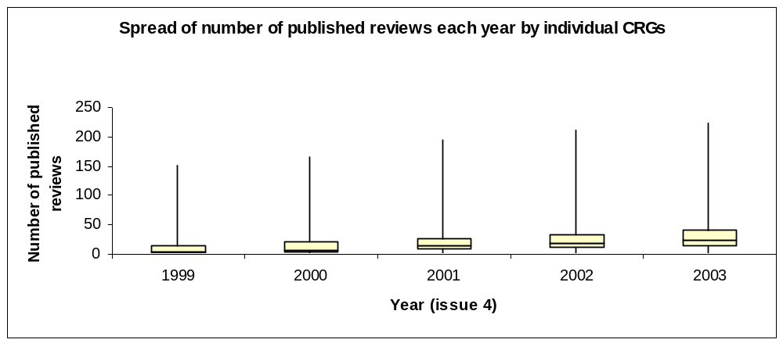
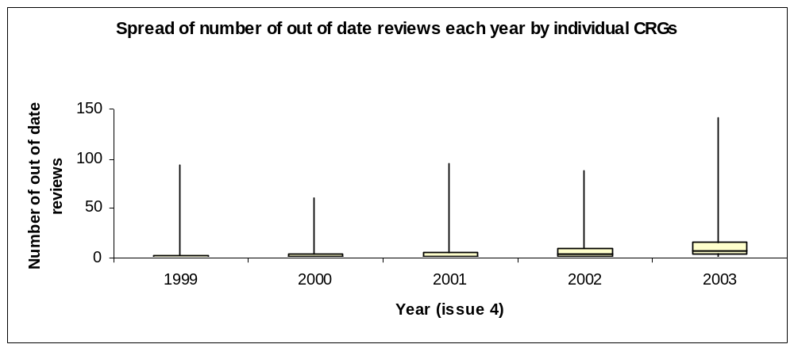
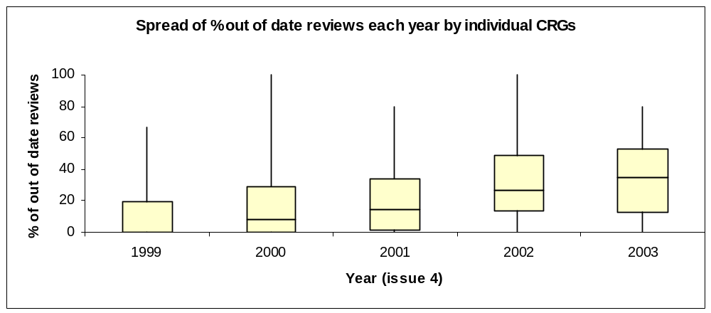
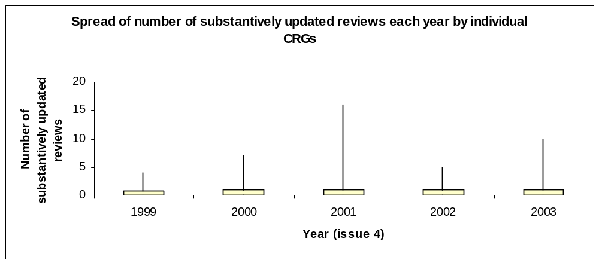
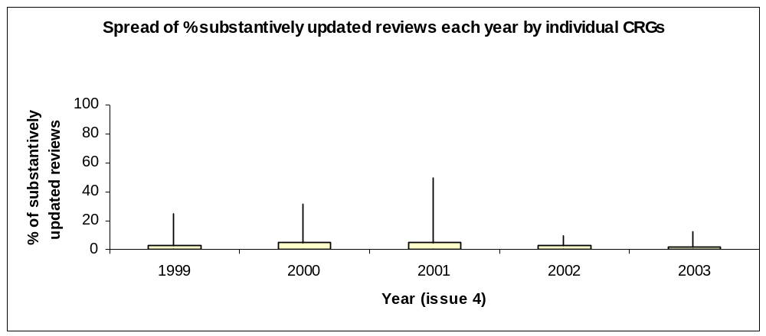

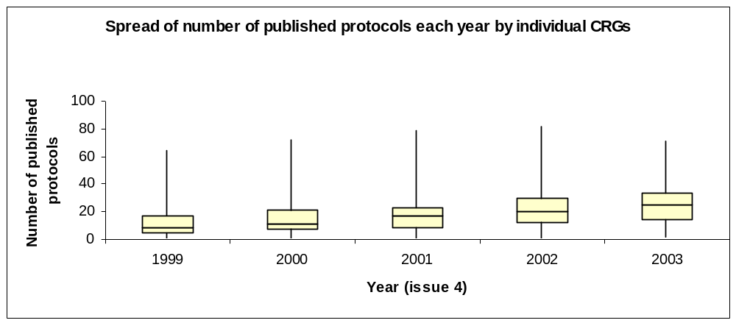
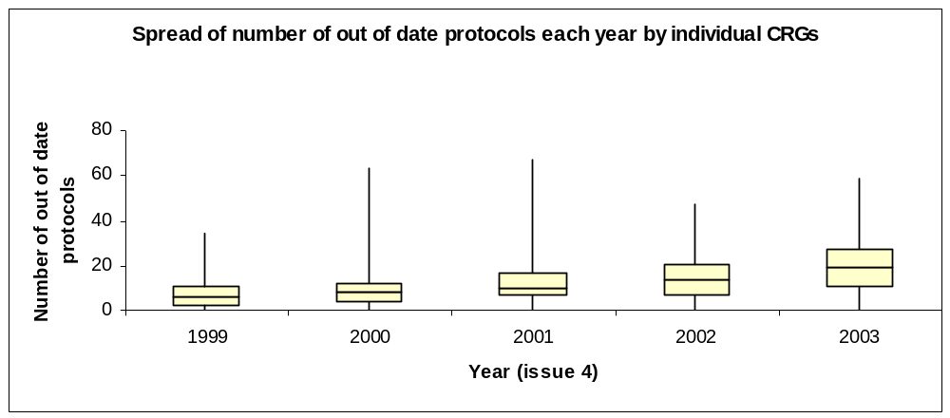
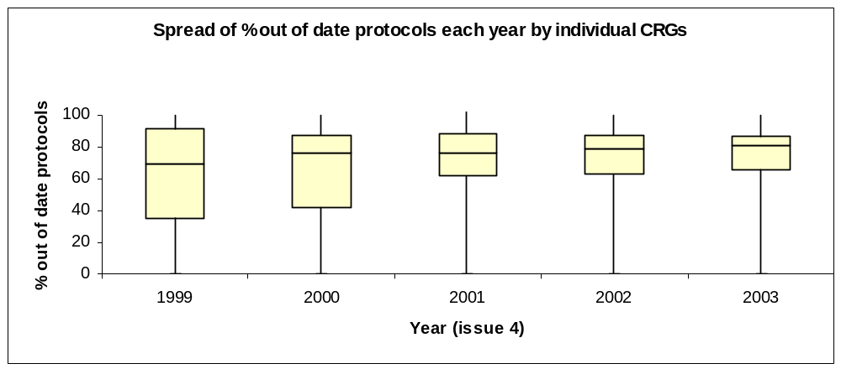
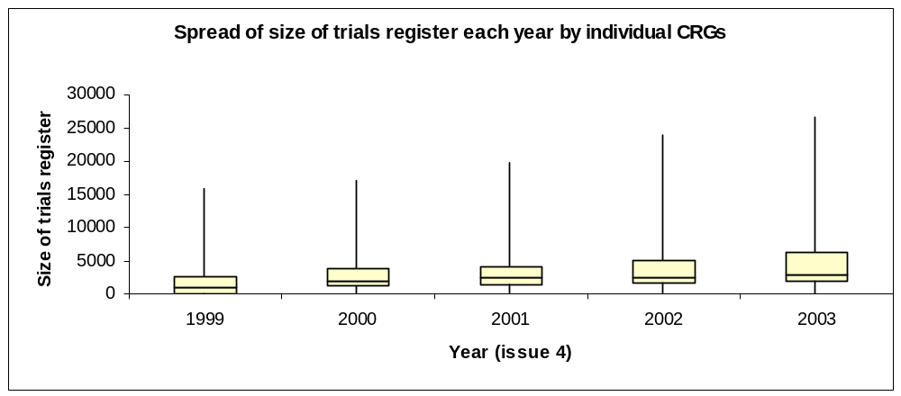

APPENDIX 3: WITHDRAWN PUBLICATIONS

NOTE: CRGs were not asked to specify whether the number they reported as ‘withdrawn’ were protocols or reviews.

Collaborative Review Group | No of withdrawn protocols | No of withdrawn reviews | Withdrawn (not specified) | Total withdrawn
Acute Respiratory Infections | 2 |  |  | 2
Back | 2 | 2 |  | 4
Colorectal Cancer |  |  | 2 | 2
Cystic Fibrosis & Genetic Disorders |  |  | 1 | 1
Dementia & Cognitive Improvement |  |  | 2 | 2
Depression, Anxiety & Neurosis | 1 | 2 |  | 3
Effective Practice & Organisation of Care |  | 1 |  | 1
Epilepsy |  |  | 3 | 3
Eyes & Vision |  |  | 1 | 1
Gynaecological Cancer |  |  | 1 | 1
Hepato-Biliary | 6 | 1 |  | 7
Hypertension |  |  | 1 | 1
Incontinence |  |  | 2 | 2
Infectious Diseases |  |  | 1 | 1
Inflammatory Bowel Disease |  |  | 1 | 1
Injuries |  |  | 2 | 2
Menstrual Disorders & Subfertility | 2 | 2 |  | 4
Musculoskeletal Injuries |  |  | 4 | 4
Peripheral Vascular Diseases |  |  | 2 | 2
Pregnancy & Childbirth | 6 | 13 |  | 19
Prostatic Diseases & Urologic Cancers |  |  | 1 | 1
Renal |  |  | 5 | 5
Schizophrenia |  |  | 2 | 2
Stroke | 7 |  |  | 7
TOTALS | 26 | 21 | 31 | 78

